REDCap logo 

COVID Employee Exposure Tracking

**Starting a New Investigation**

1. Log in to <https://redcapynh.ynhh.org> and click COVID Exposure Tracking

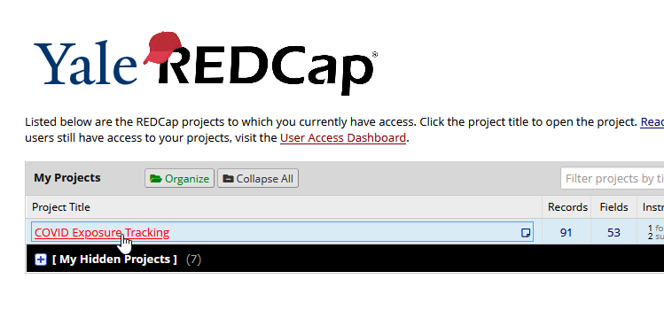

1. Click **Add/Deactivate an Exposure Event**

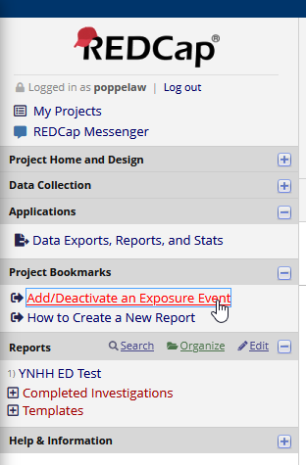

1. Fill out the form with the new **Event Label** and submit

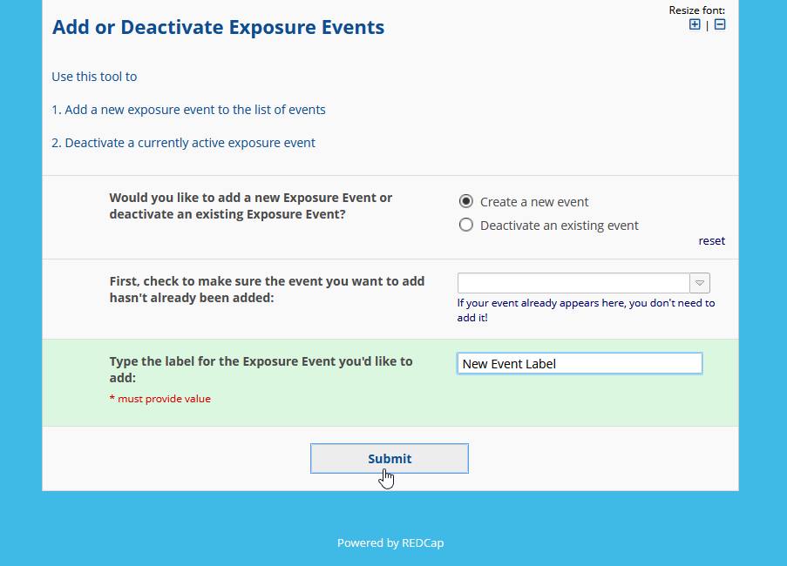

1. 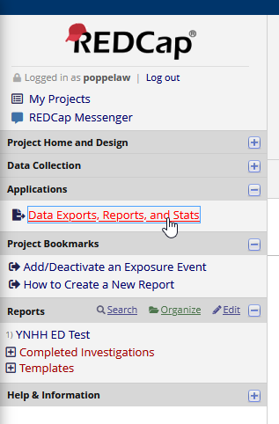Back in the COVID Exposure Tracking project, click **Data Exports, Reports, and Stats**
2. Find the **REPORT TEMPLATE** report and click **Copy**



1. Find the copy you just made and click **Edit**



1. Change the report title to match the **Event Label**

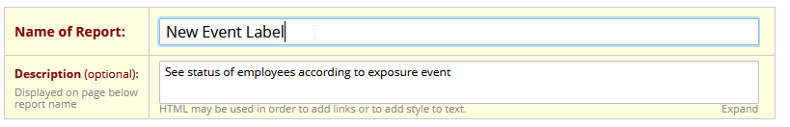

1. Select the new **Event Label** for **Filter 1**

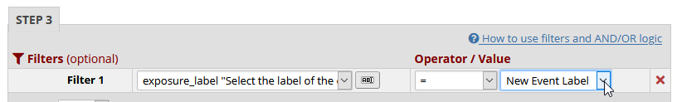

1. Click **Save Report**!

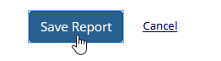

1. Give the new **Event Label** to the managers.